**Adafruit Gemma M0 CircuitPython Quickstart**

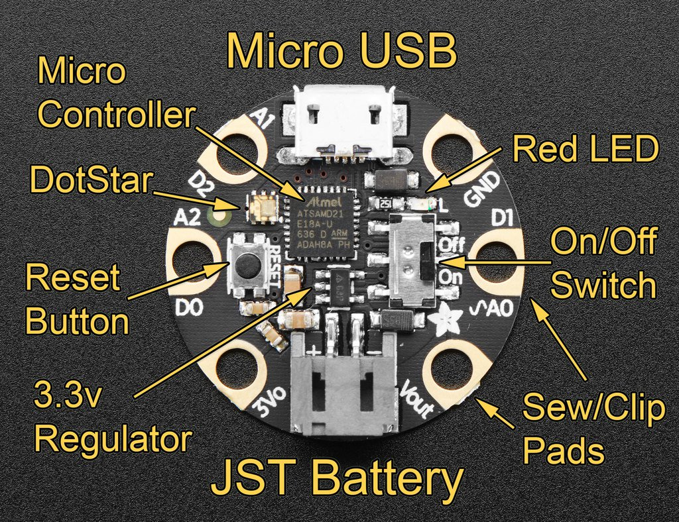

**Your Adafruit Gemma M0 has CircuitPython on board!** It’s a MicroChip SAMD21 microcontroller running at 48 MHz, with 32kB RAM and 256kB flash: 192kB for CircuitPython, plus 64kB for USB drive **CIRCUITPY**.

**Check out these Adafruit Learn Guide Links!**

**Welcome to CircuitPython:** [adafru.it/cpy-welcome](https://learn.adafruit.com/welcome-to-circuitpython)

**CircuitPython Essentials:** [adafru.it/cpy-essentials](https://learn.adafruit.com/circuitpython-essentials/)

**Gemma Guide:** [learn.adafruit.com/adafruit-gemma-m0](https://learn.adafruit.com/adafruit-gemma-m0)

**Are you on Windows 7?**

You need to install drivers before plugging in! See **Welcome->Installing CircuitPython**. Windows 10, Mac, and Linux don’t need drivers. There’s a Windows 7 driver right on **CIRCUITPY**, but prefer the downloaded version.

**Plug It In!**

Use a micro-USB cable with data (beware charge/power-only cables). A USB drive called **CIRCUITPY** will appear. If there’s a **code.py** (or **main.py**) on **CIRCUITPY**, it will run automatically. There is a demo **code.py** on the board that you have. Check it out and make a copy of it, because it has lots of example code. And you’ll find an <https://adafruit.com> discount code in the README in **CIRCUITPY**.

**Avoiding Filesystem Corruption**

Windows and Linux don’t write back data to **CIRCUITPY** immediately: they can delay for 10s of seconds. (Not an issue on MacOS.) **Eject or sync after you copy files, and always before you unplug or press the Reset button.** Otherwise **CIRCUITPY** may become corrupted. Continue reading to see editors that write immediately so you don’t need to Eject or sync every time you edit. If **CIRCUITPY** does get corrupted, see **Restoring CircuitPython and Initial CIRCUITPY** in this Quickstart.

**Editing Code**

**Mu** is the easiest editor to use: it includes a Python editor and easy REPL access. See **Welcome->  
Installing Mu Editor**. The latest version for Windows is there. (The Mac version is old.) Or, for any OS, you can use GitHub and **pip** to install the latest version. (Use a virtualenv if you want.)

git clone [https://github.com/mu-editor/mu](https://github.com/mu-editor/mut)

cd mu

pip install --user .

If you’re using an older version of Mu, it may write some sounds and image files into **CIRCUITPY**, which fills up the filesystem. Delete the files in the **images** and **sounds** folders, but not the folders themselves, or else they’ll be recreated.

If you don’t use Mu, use an editor that writes back immediately: VS Code, Atom (install the circuitpython-force-to-drive package), Sublime, gedit, vim with `-n` option, emacs, PyCharm with Safe Write. ***Don’t use*** Notepad, nano, IDLE. See **Welcome->  
Creating and Editing Code**.

**Auto-Reload**Every time you write a file, **code.py** (or **main.py**) will be re-run, unless you are in the REPL. Just edit **code.py** and see it run right away. This makes for a fast workflow.

**Libraries**

CircuitPython has builtin native libraries, but also has libraries written in Python (which are compiled into **.mpy** files to save space). Your board has a **lib** folder with some useful libraries, including the **adafruit_DotStar** and **neopixel** libraries mentioned below. If you don’t have a lib folder, you can restore the board (see below)

**Restoring CircuitPython and Initial CIRCUITPY**

In [learn.adafruit.com/adafruit-gemma-m0/downloads](https://learn.adafruit.com/adafruit-gemma-m0/downloads), you’ll find **Gemma-CircuitPython-2.3.1-PyCon.uf2**. This file contains has an even newer version of CircuitPython than is on your Gemma M0, and also all the original files on **CIRCUITPY**. To update or restore your board, double-click the reset button. The red LED will pulse, and you’ll see **GEMMABOOT** as a USB drive. Copy the **.uf2** file above to **GEMMABOOT**, wait a few seconds, and **CIRCUITPY** will reappear. ***Warning: any files you wrote to the board will go away!*** You can copy **CURRENT.UF2** from **GEMMABOOT** back to you computer to get a full backup of your Gemma, including everything in **CIRCUITPY**. (Doesn’t work on Express boards like Circuit Playground Express.)

**Talk to the REPL!**Connect to the REPL with Mu, or use **Putty** or **Tera Term** (Windows), or **screen** or **picocom** (Mac and Linux). Type Enter if necessary to start the REPL. If **code.py** is running, type ctrl-C. Type ctrl-D to soft-restart.

>>> 1+2

3

**Blink - the “Hello World” of CircuitPython!**

Make your Gemma red LED blink. Type this into the REPL or **code.py**:

import board, digitalio, time  
led = digitalio.DigitalInOut(board.D13)  
led.direction = digitalio.Direction.OUTPUT  
while True:

# led.value is True or False  
 led.value = not led.value

time.sleep(0.5)

**What’s the Temperature?**

import microcontroller

# cpu on-chip sensor

print(microcontroller.cpu.temperature)

**Capacitive Touch Detection!**

import board, touchio, time

# works for A1 and A2 also

touch = touchio.TouchIn(board.A0)

while True:  
 if touch.value:  
 print("Touched!")  
 time.sleep(0.05) # debounce

**Light up the DotStar On-Board RGB LED!**

import time, board, adafruit_dotstar

# a DotStar strip of length 1

rgb = adafruit_dotstar.DotStar(

board.APA102_SCK, board.APA102_MOSI, 1)

rgb.brightness = 0.3 # range is 0-1.0

while True:

for i in range(256):

rgb[0] = (i, 0, 0) # (r,g,b):0-255

time.sleep(0.01)

for i in range(255, -1, -1):

rgb[0] = (0, i//2, i)

time.sleep(0.01)

**Use External NeoPixels!**

We’ll have some NeoPixel rings for you to try at our CircuitPython Open Spaces at Pycon.

import time, board, neopixel  
ring = neopixel.NeoPixel(board.D1, 16, auto_write=False)  
ring.brightness = 0.1  
def wheel(pos):  
 if pos < 0 or pos > 255:  
 return (0, 0, 0)  
 if pos < 85:  
 return (255 - pos * 3, pos * 3, 0)  
 if pos < 170:  
 pos -= 85  
 return (0, 255 - pos * 3, pos * 3)  
 pos -= 170  
 return (pos * 3, 0, 255 - pos * 3)  
def rainbow_cycle(delay):  
 for j in range(0, 255, 8):  
 for i in range(ring.n):  
 idx = (i * 256 // ring.n) + j  
 ring[i] = wheel(idx & 255)  
 ring.show()  
 time.sleep(delay)  
while True:  
 rainbow_cycle(0.001)

**Read Analog Input!**

We’ll have some potentiometers at our Open Spaces.

import time, board, analogio

a0 = analogio.AnalogIn(board.A0)

while True:  
 print(a0.value)  
 time.sleep(1)

*Check out the Learn Guides mentioned at the front of this Quickstart for lots more examples, and also see the* **code.py** *that comes on the board. Come visit the CircuitPython Open Spaces and see the Adafruit folks Monday at the Sprints. Have fun!*